12

Making Rules as a Team
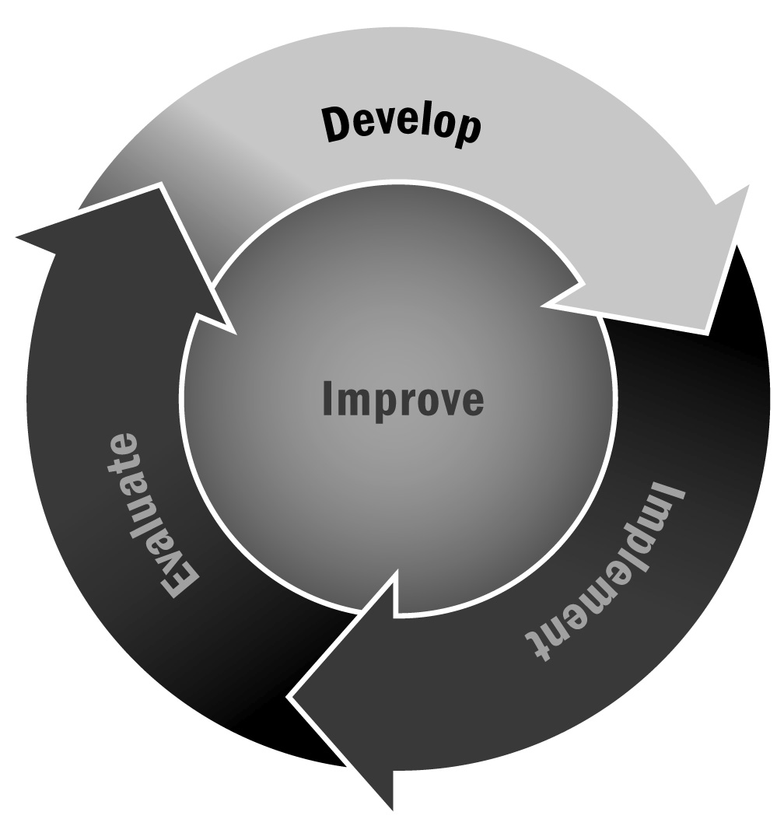
In Chapters 1 and 4, you learned that developing clear rules and guidelines at the beginning of the program with input from youth creates an environment characterized by inclusiveness where young people feel a sense of community. In addition, when youth contribute to program rules, we see reduced instances of problems because there are relevant program guidelines.
Directions: Use the following steps with program staff members and youth at the start of the program cycle. Work together to develop rules for your program.

How to Develop Rules as a Team
- Think about hopes and goals for the program as an activity. Have youth and staff members share what their hopes and goals looks like and make a list as a group (or in small groups if you have a larger group). Each person may write his or her ideas down on flip chart paper or raise a hand to share thoughts aloud with the group.
- Brainstorm a list of rules that will be needed in order to achieve the goals identified in step 1. Ask youth to share ideas for rules, and list everything each person says. This shows that everyone has a voice and that everyone’s suggestion is important.
- Suggest criteria for good rules. Example criteria may include not having too many, making sure the rules apply to everyone, clarity, and positive language.
- Clean up your list of rules. Combine any duplicates and ask if anything is missing. Ensure that the rules are clear. If there are too many rules or the rules are too complicated, ask youth to prioritize or simplify.
- Talk about common rules in life (school rules, rules at home). Discuss the commonalities and differences between common rules and the list you came up with, and why. This is important to talk about so that rules like “be quiet in the classroom” are common in school but not in the afterschool and expanded learning program (we hope!); then youth should have the opportunity to process this totally acceptable difference. It is also nice to talk about rules that might be the same everywhere, like “be a good helper.”
- Document the rules and post them somewhere in the program space where they are easily visible to all youth, staff, and program partners.
- Review the rules periodically to ensure that they are relevant.
Remember: It is important not only to develop and agree to the rules as a group but also to determine the consequences of not following the rules. These activities will help youth in identifying the cause of their own behavior and coming up with proactive plans to improve.

